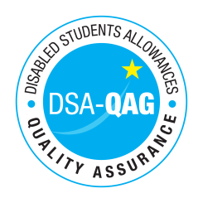
Moulton College - NMH Rates

Period covered - 01/04/2017 through to 31/03/2021

The table below shows NMH rates. The greyed out cells indicate that the NMH provider does not offer these services.

Note: NMH Support Rates shown per hour in the table below.
 | Standard Rate (in-person) |  |  | Distance Learning only (in-person, in-home |  |  | Remote Delivery (e.g. Facetime/Skype or similar) Only
 | Net | VAT | Total | Net | VAT | Total | Net | VAT | Total
Band 4 Specialist Access and Learning Facilitators
Specialist 1:1 Study Skills Support - SpLD | 60.00 | 00.00 | 60.00 |  |  |  | 60.00 | 00.00 | 60.00
Specialist 1:1 Study Skills Support - AS | 60.00 | 00.00 | 60.00 |  |  |  | 60.00 | 00.00 | 60.00
*Please delete any rows where you do not provide this support role

