Kettering Mind Self-Referral Form
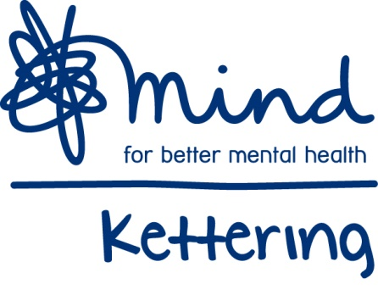

Part 1
Personal Details
Name |  |  |  |  | Date of Birth:
Gender |  |  | Ethnicity:
Tel No: |  |  | Full Address:
Next of Kin:  Tel No: |  |  | GP Surgery:
Do you give consent for us to leave messages relating to your referral? |  |  |  |  |  |  |  | Yes / No
Do you have any access requirements?  (please describe) |  |  |  |  |  |  |  | Yes / No
Do you give consent for us to send emails relating to your referral? |  |  |  |  |  |  |  | Yes / No
If yes, please print your email address:

How did you hear about Kettering Mind?
Please sign below to acknowledge and give consent to notes being recorded on Kettering Mind systems;

Signature: Date
About you
- Please describe some of the mental health difficulties you are experiencing:

What areas of your life are most affected? |  |  |  | What feelings are you most troubled by?
Work  Home  Relationships |  | Finances  Physical Health  Parenting |  | Sadness  Stress  Grief |  | Anxiety / Panic  Shame or Guilt
Other (please describe) |  |  |  | Other (please describe)
- Have you had difficulties in the past and did you seek any help and support? If so what, or who helped?

- What support do you feel you would benefit from?

Wellbeing Courses (anxiety management, anger management, CBT)

Therapeutic Groups (arts/crafts, music, gardening)

Social Support

- Do you have any ethnic, gender, culture & diversity needs we can support you with whilst attending Kettering Mind?

Part 2
Please fill in all the questionnaires, as it will help us tailor the support to the individual We will ask individuals to fill in identical questionnaires at the end of support, for comparison.

Mental Wellbeing Questionnaire
The Short Warwick-Edinburgh Mental Well-being Scale (SWEMWBS)

Over the last 2 weeks, how often have you experienced any of the following: |  | None of the time | Rarely | Some of the time | Often | All of the time
I’ve been feeling optimistic about the future |  | 1 | 2 | 3 | 4 | 5
I’ve been feeling useful |  | 1 | 2 | 3 | 4 | 5
I’ve been feeling relaxed |  | 1 | 2 | 3 | 4 | 5
I’ve been dealing with problems well |  | 1 | 2 | 3 | 4 | 5
I’ve been thinking clearly |  | 1 | 2 | 3 | 4 | 5
I’ve been feeling close to other people |  | 1 | 2 | 3 | 4 | 5
I’ve been able to make up my own mind about things |  | 1 | 2 | 3 | 4 | 5
SWEMWBS total score

GAD7 Anxiety and Depression Questionnaires
Over the last 2 weeks, how often have you been bothered by any of the following problems? |  |  | Not at all | Several days | More than half the days | Nearly every  day
1 | Feeling nervous, anxious or on edge |  | 0 | 1 | 2 | 3
2 | Not being able to stop or control worrying |  | 0 | 1 | 2 | 3
3 | Worrying too much about different things |  | 0 | 1 | 2 | 3
4 | Trouble relaxing |  | 0 | 1 | 2 | 3
5 | Being so restless that it is hard to sit still |  | 0 | 1 | 2 | 3
6 | Becoming easily annoyed or irritable |  | 0 | 1 | 2 | 3
7 | Feeling afraid as if something awful might happen |  | 0 | 1 | 2 | 3
 | GAD7 total score

PHQ-9
Over the last 2 weeks, how often have you been bothered by any of the following problems? |  |  | Not at all | Several days | More than half the days | Nearly every day
1 | Little interest or pleasure in doing things |  | 0 | 1 | 2 | 3
2 | Feeling down, depressed, or hopeless |  | 0 | 1 | 2 | 3
3 | Trouble falling or staying asleep, or sleeping too much |  | 0 | 1 | 2 | 3
4 | Feeling tired or having little energy |  | 0 | 1 | 2 | 3
5 | Poor appetite or overeating |  | 0 | 1 | 2 | 3
6 | Feeling bad about yourself — or that you are a failure or have let yourself or your family down |  | 0 | 1 | 2 | 3
7 | Trouble concentrating on things, such as reading the newspaper or watching television |  | 0 | 1 | 2 | 3
8 | Moving or speaking so slowly that other people could have noticed? Or the opposite — being so fidgety or restless that you have been moving around a lot more than usual |  | 0 | 1 | 2 | 3
9 | Thoughts that you would be better off dead or of hurting yourself in some way |  | 0 | 1 | 2 | 3
 | PHQ9 total score

Form reviewed March 2020
Registered Charity number 1069373 Registered Company number 03530898

