____________________________________________________________________
MOULTON COLLEGE – JOB DESCRIPTION
____________________________________________________________________

Job Title: Facilities Administrator

Department: Facilities Management Division

Hours: 37.5 hours per week. Weekend and evening working may be required when business needs demand.

Responsible to: Facilities Manager

Salary / Scale: Business Support Spine - Band 7 (£22,868.00 - £24,954.00 per annum)

Date of Issue: March 2023

Organisation Chart:
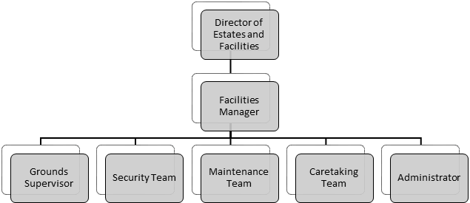

______________________________________________________________________

- Aims and Purpose of the Post

  - The collection and processing of financial, compliance and physical records for the Facilities Management function.

  - The collection and processing of records and data in relation to the monitoring of health and safety in facilities management.

  - Support the administration of the facilities helpdesk solution ensuring jobs are recorded, allocated and closed in line with SLAs (Service Level Agreements).

  - The organisation and running of the Facilities Management Office and providing administrative support to the Facilities Management Team and Health and Safety Manager.

- Specific Responsibilities

  - To collect, check and record all compliance, physical and financial data relating to facilities management as required by College Management, the Governing Body and other regulatory bodies.

  - To check, prepare and record all pro-forma orders issued by the manager.

  - To prepare, check and record all invoice requests issued by the manager.

  - To carry out administrative procedures effectively, including reports required by the management and statutory and internal returns.

  - To maintain a database of all facilities management Risk & COSHH Assessments, to monitor and inform staff of review dates.

  - To maintain a database of all statutory and insurance inspections, internal and external and to monitor these and inform staff of review dates.

  - To carry out administrative procedures relating to the effective running of the facilities helpdesk solution ensuring all jobs are accurately recorded, allocated and closed in line with SLA.

  - To assist the Facilities Manager with general administration.

  - To act as secretary to the Health & Safety Committee.

  - To promote the welfare of young people and vulnerable groups in all aspects of College life and to ensure safeguarding arrangements are adhered to at all times.

  - The active promotion of and commitment to best practice in equality, diversity & inclusion.

  - Contribute and demonstrate fully and at all times the positive promotion and role modelling of the College core values, generic competencies and professional behaviours expected of all staff employed by Moulton College.

  - Undertake any other duties as required by the Principal and as may be reasonably expected commensurate with the post. This may include either the temporary or permanent re-deployment to an equivalent grade of post within the organisation.

This job specification represents the major tasks to be carried out by the post holder and identifies the level of responsibility at which the post holder will be required to work. In the interests of effective working the major tasks may be reviewed from time to time to reflect the changing needs and circumstances. Such reviews and any subsequent changes will be carried out in consultation with the post holder. All members of staff are appointed to the College as a whole and may reasonably be asked to undertake similar or related duties in an operational area or faculty other than that to which they were originally appointed.

Core Benefits;
Local Government Pension Scheme Health Cash Plan (subject to conditions)
33 days holiday (inc bank/public holidays)** 10% discount on College courses
On-site Gym Free on-site parking
Subsidised catering Cycle to Work Scheme

(** Pro rata for part time)

I confirm my acceptance of the role as outlined above and agree to apply myself fully to the responsibilities of the post.

Signed;……………………………… Date;………………………………

POSITIVELY PROMOTING EQUALITY, DIVERSITY & INCLUSION

Person Specification; Administrator - Buildings & Resources

 | Essential | Desirable
Qualifications
Educated to degree level or equivalent |  | X
Minimum of grade C in GCSE Maths and English Language (or equivalent) | X
Commitment to and evidence of CPD | X
Experience & knowledge
Experience of working in a similar role | X
Experience of monitoring budgets |  | X
Experience of working with confidential information | X
Experience of dealing with large volumes of data and information | X
Experience of dealing with customers | X
Experience of working in Education or similar environment. |  | X
Ability / Skills
Thorough working knowledge of Microsoft Word and Excel | X
Ability to read, analyse and interpret information | X
Ability to present information effectively and respond to questions from employees and customers | X
Ability to operate standard software packages | X
Outstanding organisational and administrative skills | X
Able to maintain total confidentiality | X
Outstanding interpersonal communication skills | X
Committed to providing an outstanding customer service | X
Personal Attributes
Flexible approach to work to allow for evening and weekend working. | X
Willingness to operate flexibly | X
Evidence of ability to improve customer satisfaction | X
Strong team player | X
Safeguarding
Satisfactory enhanced DBS disclosure | X
Displays awareness, understanding and commitment to the protection and safeguarding of children and young vulnerable adults. | X
Commitment to policies on child protection, health and safety, confidentiality, student behaviour / discipline and equal opportunities | X

NOTE;
All candidates will be asked for proof of their eligibility to work in the UK during the interview and selection process. Tier 2 Certificates of Sponsorship are restricted by the UK Visas and Immigration Service and the position advertised above is unlikely to qualify for sponsorship. We are therefore unable to consider applications from candidates requiring Tier 2 immigration status to work in the UK at this time. For further information please visit the UK Visas and Immigration Service Website

